|  |  |
| --- | --- |
|  | Office of the National Coordinator for Health IT  Federal Health Architecture  Program Management Office |
|  |  |
| FHA Federal Health Information Model  (FHIM)  Model-Driven Architecture (MDA) Implementation Modeling Process Guide | |
|  | Version 1.0  9/1/2014 |

Contents

TOC \t "Heading 1 A, 1,Heading 2 A, 2,Heading 21, 3,Title2, 4"

1. Background PAGEREF _Toc \h 4
2. Goal PAGEREF _Toc1 \h 4
3. Approach PAGEREF _Toc2 \h 5

Implementation Guide Model PAGEREF _Toc3 \h 6

Use Cases Package/Section PAGEREF _Toc4 \h 6

Implementation Profile Model Package/Section PAGEREF _Toc5 \h 7

Focal Class(s) PAGEREF _Toc6 \h 7

Ancillary Classes PAGEREF _Toc7 \h 7

Data type Profiles PAGEREF _Toc8 \h 7

Constraints PAGEREF _Toc9 \h 7

1. Tools PAGEREF _Toc10 \h 9
2. Repository PAGEREF _Toc11 \h 10
3. High-Level Process PAGEREF _Toc12 \h 10
4. Detailed Model-Driven Process to create Implementation Guides PAGEREF _Toc13 \h 12

Interoperability Requirements PAGEREF _Toc14 \h 15

Create snapshot copies of relevant classes PAGEREF _Toc15 \h 15

PSM-specific annotation are added to the FHIM PAGEREF _Toc16 \h 15

Constrain Data type to a Profile PAGEREF _Toc17 \h 15

Constrain elaborated/snapshot classes according to use cases PAGEREF _Toc18 \h 16

Substitute data types PAGEREF _Toc19 \h 16

Identify elements that are not supported PAGEREF _Toc20 \h 16

Identify mandatory data elements PAGEREF _Toc21 \h 17

Add Coding System constraint PAGEREF _Toc22 \h 18

Add Value Set constraint PAGEREF _Toc23 \h 18

Add fixed value constraint PAGEREF _Toc24 \h 19

Assign unique identifier to each constraint predicate PAGEREF _Toc25 \h 20

Apply Constraint Model to Target Interchange Standard PAGEREF _Toc26 \h 20

Glossary PAGEREF _Toc27 \h 22

1. Background

The Federal Health Information Model (FHIM) was conceived as a basis for consensus-building among federal partners and as a consistent, model-driven architecture approach to healthcare interoperability. This paper explores the role that the FHIM could play in the future as an enabler for requirements analysis, harmonization, standards profiling and implementation. This process document describes the steps and lessons learned from creating a prototype that demonstrates the integration of the FHIM, and related terminologies and value sets, with the Model-Driven Health Tools (MDHT) from Open Health Tools (OHT) to produce HL7 Clinical Document Architecture (CDA) and National Information Exchange Model (NIEM) compliant specifications and implementation standards.

The FHIM is intended to represent the data elements and the relationships between data elements along domain. The FHIM is both platform and standard neutral to allow implementers to represent the contents identified in the FHIM using any technology or standard representation by relating the contents of data element organized along domain into use-cases specific payloads that support a specific set of needs. The FHIM domains are derived and based on business areas. Once an interoperability use case is identified, the FHIM data element required to support the use case

The premise of the FHIM prototype is relatively straight forward: to illustrate the use of the FHIM as a Platform Independent Model (PIM) that, when combined with an initial Domain Specific Language (DSL) supporting Constraints on Interchanges, can generate Platform Specific Models (PSM) and artifacts for CDA or NIEM using a corresponding Platform Definition Model (PDM) that supports Semantic Model Metadata Mapping.

1. Goal

The goal of this document is to provide guidance to implementers interested in creating semantically-interoperable standard-based specifications (implementation guides) using the FHIM as the underlying source of constraints and using Model-Driven-Architecture principles to add project-specific constraints. This document will illustrate how implementers may reuse classes of data defined in the FHIM to create implementation guides for specific interoperability standards (i.e. Platform-Specific-Models) using a generic or logical set of constraints (i.e. Platform Independent Model). The resulting implementation guides will be modeled, published as standards specification, and used for code generation. The basis for the approach is that the information requirements are represented in a standard-based UML model that is platform-interdependent representation of interoperability needs applicable to any platform-specific interoperability standards. This allows implementers to represent their needs once and then create interchange-specific implementation guides as needed.

1. Approach

Information constraints organized into “Implementation Profiles” are a way to specify how a standard-based specification is used to exchange semantically-precise and interoperable payloads across dissimilar systems. Constraints are also a way of establishing conformance to a specific implementation guide of a base standard. NIST relies on these constraints to validate payload instances (i.e. messages, documents) against the requirements in an implementation guide. Using the FHIM to specify domain-wide constraints regarding the classes attributes, and associations we can create general-purpose constraint models for one or more profiles. The profiles are abstract constraints applied to an interchange standard. When they are applied to a specific standard (e.g. CDA) they are transformed into the equivalent specific to that interchange format (e.g. CDA template).

The FHIM represents the consensus source of data elements used for interoperability and it draws on requirements formulated by Federal partners in other setting (e.g. HL7 Domain Analysis Models, HL7 Functional Information Model). In this role, FHIM can serve a logical model of reusable constraints that may be applied to any interchange standard. This document illustrates how the constraint based on FHIM may apply to specific standards required for Meaningful Use and provides a path for reusing the same set of information requirements to exchange information using future information exchange formats.

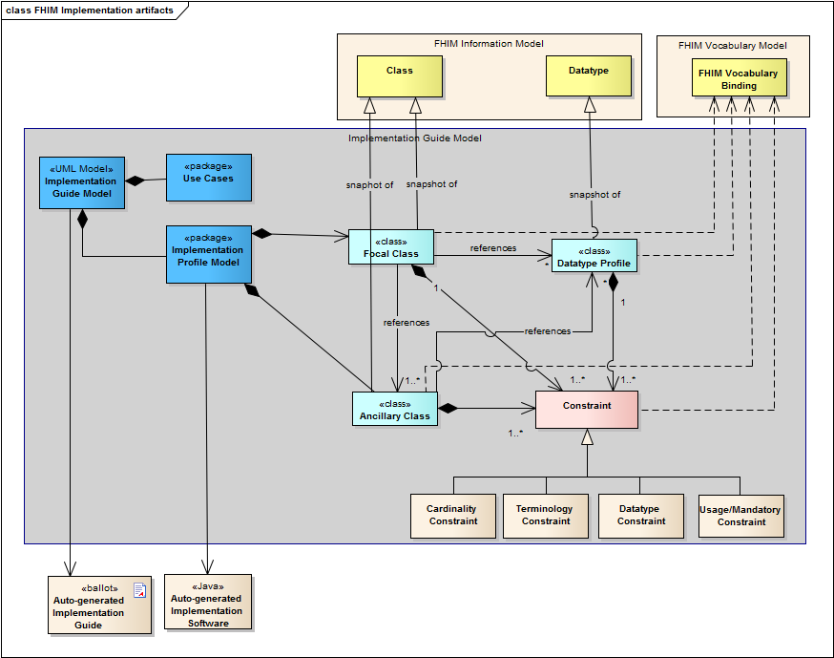

Figure 1: MDHT Implementation Artifacts

The diagram above represents the structure of an implementation guide model used to generate PSM-specific implementation document and implementation/validation artifacts:

Implementation Guide Model

The Implementation Guide model contains the use cases corresponding to the project requirements along with a model of information require. This model is basis for generating an implementation guide and implementation artifacts for a project.   
It references the FHIM terminology model and it contains two additional packages/sections:

Use Cases Package/Section

This package contains the interoperability use cases and user stories.

Implementation Profile Model Package/Section

This package contains is a set of classes, associations, and data types along with the constraints applied to them to meet the needs of a specific project, based on the interoperability use cases. The classes in the implementation profile model are subject to elaboration and they are eventually related to platform-specific construct such as CDA template or NIEM object.

Focal Class(s)

An implementation profile model contains one or more focal classes. This class represents the business object at the center of the interoperability use case. It may be a "Patient" class if the interoperability requirements revolve around the state changes of a patient. Otherwise the focal class may "Encounter" if the messages deal with the admission/transfer/discharge of a patient.

Ancillary Classes

An ancillary class profile contains information associated with focal class that is constrained in a way consistent with the project requirements. The elements of ancillary classes may be subject to constraints.

Data type Profiles

A data type profile is a constrained specialization of an existing data type that is applicable to specific implementation guide and a certain set of interoperability use cases. The Data type Profile is used to replace the original FHIM data type in the definition of a class attribute.

Constraints

Constrains are applied to any data elements to specify not only more detailed semantics but also data type, cardinality, usage, terminology, or fixed value constraints.

Since the Implementation Guide Model is primarily a way of representing constraints that may apply to a variety of platform-specific interchanges (e.g. NIEM, HL7 CDA, HL7 V2.x) the types of constraints must be sufficiently generic to apply to any target PSM:

* **Class and Attribute Semantics** constraints are based on a consensus understanding of the data elements. The FHIM assigns meaning to classes, attributes, and associations between classes of objects. The semantics are transferred to the data elements (e.g. segments, fields, clinical statement, etc.)
* **Associations** between object are specified very clearly in FHIM but are often under-defined are ambiguous in the interoperability standards. “Nesting” or “looping” segments is the typical way to identify how related classes of objects are related to each other using a typical messaging specification. Similarly, CDA documents are similarly deficient in specifying associations between clinical statements/entries specified in different section of a document. The need to have a source-of-truth for associations between classes of objects is very important to understanding the context of a data element and removing any ambiguity. Similar to attributes, FHIM associations can be a source of constraint predicates applied to the target PSM (i.e. base standards CDA, NIEM, HL7 Version 2.x using pre-defined transport specification like IHE XDS.b).
* **Data Element Usage/Mandatory** constraints that identifying whether an association or attribute should appear in the FHIM domain or in specific payload based on the contents of one or more FHIM domains.
  + **Cardinality** or repetitions of an association or attributes. The cardinality is also used to identify a data element that is excluded/not supported. If the cardinality is 0..0 then the constraint will identify the data element is not supported in that implementation guide as specified in its interoperability use cases.
  + **A mandatory usage constraint specifies** that a data element or association must be specified in a specific payload. The use of a specific optional element may be required for a specific interoperability use case. However, the FHIM will enforce specific mandatory elements that are intended to be present in any payload derived from FHIM. This ensures consistency across use cases and across data representations.
  + **Usage keywords** (e.g. SHALL, SHOULD, MAY) Some data elements specified as “optional” or “undefined” in the FHIM may be specified as “required” or “ not supported” in a specific use case. The constraints applied to the FHIM may be represented in an interchange-specific way but it is always very important to capture these requirements in a clear and reusable format.
* **Data type** constraints for complex data types (e.g. person name, address, telephone and other telecommunication numbers) that appear in the messages and document. This type of constraint results in constrained data structures that are reused in a single structure. The FHIM will identify which version of a constrained Person Name is assigned to a patient name in one context versus another. The ability to constrain and reuse these data types allows for harmonization of basic concepts such patient identify across information exchange standards. The data type constraints fall into two categories:
  + **Data type substitution** (e.g. Any is replaced by ST) where a more generic data type is replaced by a more specific, derived data type. A FHIM class may specify a generic type while an implementation guide may require that the type be further constrained and replaced by a more specific type. This type of substitution is common to HL7 Version 3 and CDA implementation guides.
  + **Data type profiling** (e.g. PN-Person Name- is constrained to specificset of use cases to contain a specific suffix**)**. The data type profile is similarly substituted for that specified in the FHIM original class attribute.
* **Vocabulary** constraints apply to coded attributes. These constraints reference value sets or coding systems specified in the FHI Vocabulary model.
  + The FHIM may specify the Coding System or Value set binding
  + Value set allowed for coded attributes
    - Value sets may be explicitly enumerated or predicate-based
    - The MDHT tools will create tools to validate constraints based on explicit value sets
  + Fixed value – in certain cases an attribute value is fixed for specific context and the MDHT allows developed to record and ensure these values are validated at runtime by the auto-generated code.

The constraints are the basis for generating computable constraints and the associated Java code for creating, and parsing PSM-based payloads consistent with requirements of a specific project and implementation guide. The MDHT tools generate the Java classes used for reference implementations of conformant payload and for validation/verification of such payloads are runtime or during testing.

1. Tools

The Open Health Tools Model Driven Health (MDHT ) generator tools extracts the constraints from the FHIM and the associated implementation guide model and creates the documentation and associated runtime libraries for creating, parsing, and validating platform-specific payloads that conform to the logical constraints specified in the Implementation Guide Model.

All the examples presented in the appendices to this document are created using the MDHT tools intended to generate platform-specific implementation artifacts for a variety of interchange standards:

* NIEM
* HL7 CDA (including Consolidated CDA)
* HL7 Version 3
* HL7 Version 2.x (in progress)

1. Repository

All the artifacts referenced in this document are available on the FHIMS project site on the MDHT GForge:

<https://www.projects.openhealthtools.org/sf/projects/fhims/>

1. High-Level Process

The following is the overall high-level process used to model the information exchange requirements of a stakeholder community using a common model that is constrained for specific interoperability use cases. These requirements are represented using a set of common patterns, classes, and data types into a series of information business areas/domains organized into a Platform Independent Model (PIM) - FHIM. They are subject to constraints and code generation consistent with the OMG Model-Driven-Architecture approach.

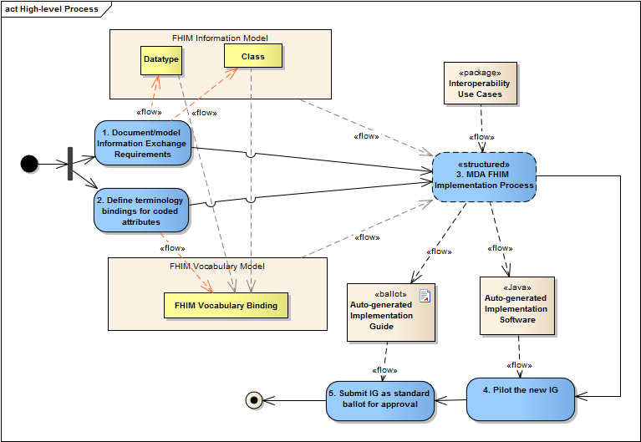

Figure 2: High-level FHIM Implementation Process

1. **Document the information required for exchange in the FHIM Information Model**. FHIM is a platform independent model (PIM) model describing the information exchange requirements of FHIM stakeholders. The result of this activity is to create a FHIM UML model organized into packages/domains. Each domain contains the information required to exchange information among systems in a specific business area.
2. **Define terminologies and value sets for coded data attributes in the FHIM Vocabulary model.** This FHIM Terminology is a UML model that contains all references to all coding system and value set versions used by coded attributes of FHIM classes. This model will also contain coding system version and subsets used by implementation guides based on FHIM.
3. **Follow a Model Driven Architecture (MDA) process guide to produce a draft implementation guide as described in section 7**. The following is a high-level summary of the approach:
   * Identify the specific use case(s) for exchange of information
   * Identify the target Platform Specific Model(s) (PSM) to support the exchange
   * Constrain the FHIM and associated terminologies/value sets to generate a PIM that contains the information needed to support the use case
   * Use the use case PIM to generate the target PSM
   * Use the PSM to generate artifacts for the target implementation standard
4. **Pilot test the draft implementation** containing constraints and extensions to the base standards in PSM and based directly on the contents of the PIM
5. **Submit the draft implementation guide to an SDO/SRO for ballot/approval;** if the project requirements require specific extensions in the base standards (i.e. PSM) additional change requests will be submitted for each extension or gap that needs to be addressed.
6. Detailed Model-Driven Process to create Implementation Guides

The process used to create an implementation guide for an interoperability standard, relies on the use of FHIM contents to specify the “profile model” of data and constraints needed to meet the interoperability use cases of a project.

Each implementation guide is documented in a separate package in the FHIM workspace that references the classes specified in the FHIM. The structure of an implementation guide is:

* **Implementation Guide Model:** containing the use cases for interoperability and a profile model:
  + **Use Case Package**
    - Interoperability Use case descriptions including pre- and post-conditions for information exchanges.
      * The use case may identify a specific type of business objects that are involved in the exchange (e.g. Patient, Encounter, Sample, Order, and Observation Result).
    - Identified human and system actors involved in information exchanges. The systems actors may represent specific types of system. An EHR system may play one or more roles in an interoperability use case.
  + **Implementation Profile Model Package**
    - Snapshots/copies of FHIM classes including:
      * Focal class(es) corresponding to the focal objects that are the subject of interoperability (e.g. Patient, Encounter, Sample, Order, Observation Result).
      * Related classes that supply context to the focal objects (e.g. target records, author, custodian, ordering provider, etc.)
      * If the FHIM classes do not already contain PSM-specific annotations identifying the structure used to exchange their content, the profile model may add that. Ideally this PSM-specific code generation tooling guidance should be added to the original FHIM classes.
    - Constraints applied the classes, associations and attributes in the model including:
      * Semantic clarifications
      * Cardinality constraints for associations and attributes
      * Usage/mandatory constraints for associations and attributes
      * Terminology and fixed value constraints (these constraint apply to attributes only)

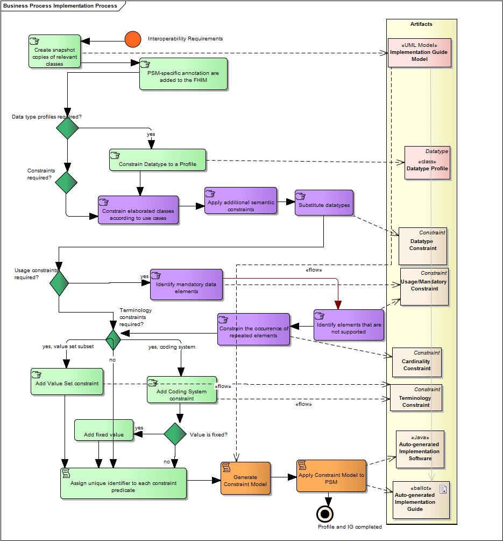

Figure 3: MDHT Implementation Process Overview

The diagram above represents the process used for developing an implementation guide model used to generate PSM-specific implementation document and implementation/validation artifacts:

Interoperability Requirements

The implementation process starts from a set of well-defined interoperability requirement recorded as use cases. The FHIM is used to implement data interchange requirements based on project user stories, project use cases, project functional requirements, or even standard-based domain analysis models produced by HL7 projects.

In addition to project-specific requirements and interoperability use cases, the process of implementing the FHIM may start as a need to support specific function in an HL7 Functional Profile or Functional Model. Future versions of the HL7 Functional Model will provide information model for interoperability in addition to a functional decomposition of the EHR system functionality,

Create snapshot copies of relevant classes

Based on the project use cases, the modelers will identify, in the FHIM, the focal and ancillary classes required to meet the project needs. For each these classes the modeler creates an equivalent copy in the Implementation Guide Package. It allows both to trace to the appropriate version of a FHIM class and to manage change to the IG over time.

PSM-specific annotation are added to the FHIM

These PSM-specific annotations inform the transformation engine how to translate the FHIM classes to a structure specific to that PSM. These annotations allow a single FHIM structure to be transformed into any PSM/interchange standard structure thus making the FHIM more reusable and applicable to current and future interoperability needs. Annotations may be added to the FHIM classes directly and overridden in a specific IG but the best-practice is to maintain the PSM-specific annotation in the FHIM for maximum reuse.

* + Refer to Appendices A, B, and C for examples of annotations applied to FHIM classes in order to enable generating the correct implementation artifacts.

Constrain Data type to a Profile

The constrained data type will be later applied to specific attributes. A new, implementation-guide-specific data type is created from a FHIM data type. For instance the use of address structure may need to be constrained according to specific IG requirements. The constrained version of the address data type will be specified as a data type profile and applied to the IG classes replacing the FHIM/default data type. The data types are constrained similar to any other classes following the process described here.

Constrain elaborated/snapshot classes according to use cases

The snapshot classes are constrained according to the use cases and the interoperability requirements of the project

Substitute data types

If needed, an attribute's type may be replaced with the specialization of that data type or with a data type profile. The substitution rule mandates that a data type may be replaced with a more specific/derived data type but cannot be replaced with an unrelated or more generic type.

* The attribute data type may be selected and replaced with a data type profile or a derived data type specified in the FHIM Datatypes domain.

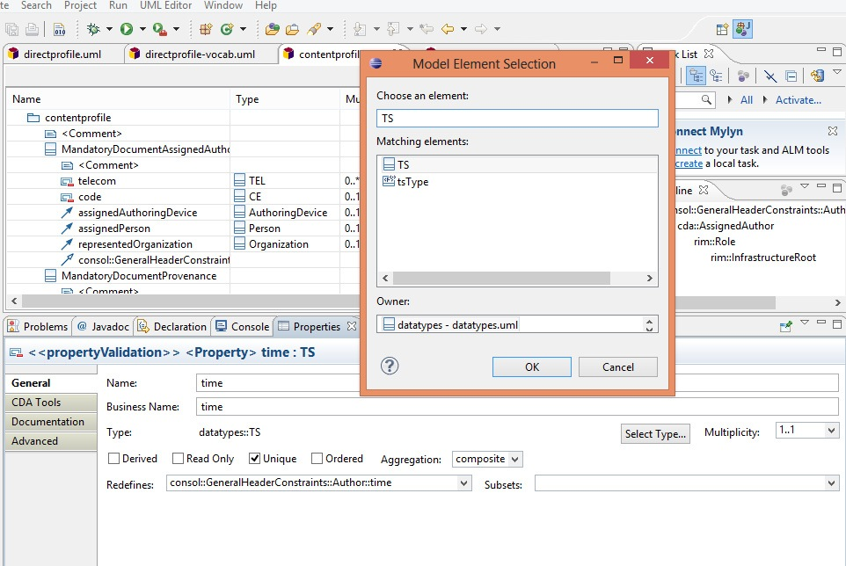

Figure 4: Data type substitution and constraint dialog

Identify elements that are not supported

The items that are not supported are marked with cardinality 0..0. The MDHT tools interpret this as a "SHALL NOT" or "not supported" constraint on the base attribute or association.

* The cardinality is set to 0..0” to indicate an attribute or association is not supported:

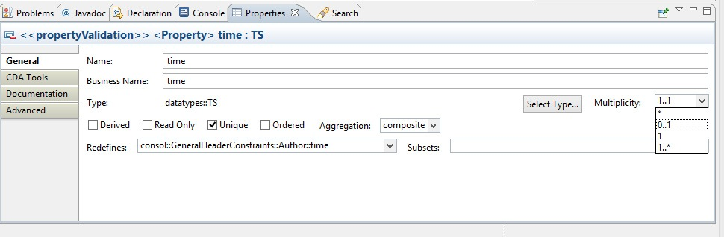

Figure 5: Cardinality is changed to indicate that the element is not supported

Identify mandatory data elements

The mandatory attributes and association as marked as "SHALL" or "Required". Additionally, the MDHT tools allow a "mandatory" flag to identify those attributes that are not allowed to be set to null using the PSM specific indicators (e.g. a null flavor for HL7 V3 and CDA, a "" for HL7 Version 2).

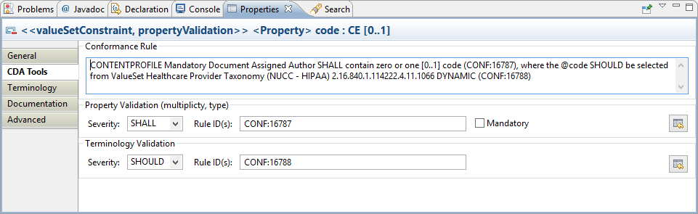

Figure 6: Usage is set but the element may be null

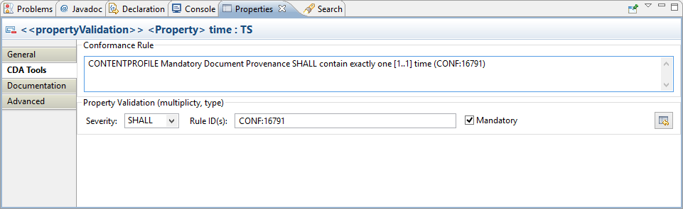

Figure 7: The "mandatory" flag is set if the element may be no be null

Add Coding System constraint

If the original coded attribute was not constrained, the constraint may identify a specific terminology system.

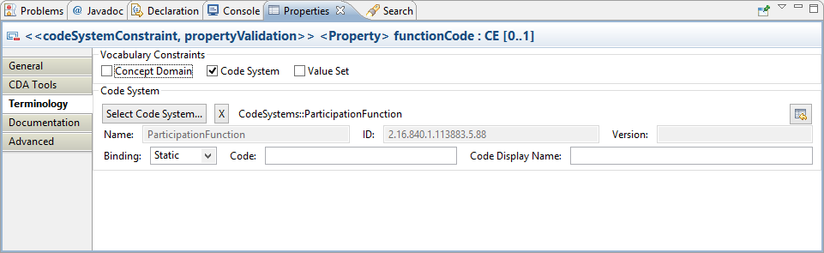

Figure 8: If the "Code System" is checked, then the "Select Code System..." button is enabled

Add Value Set constraint

This would be a further constraint to refer to a value set that is subset of the values allowed in the original class.

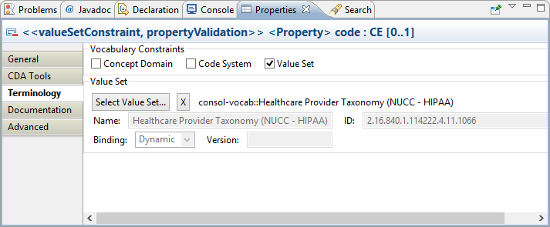

Figure 9: Select "Value Set" and press "Select Value Set..." button

Add fixed value constraint

In some cases the value of attribute is constrained down to single allowed value.

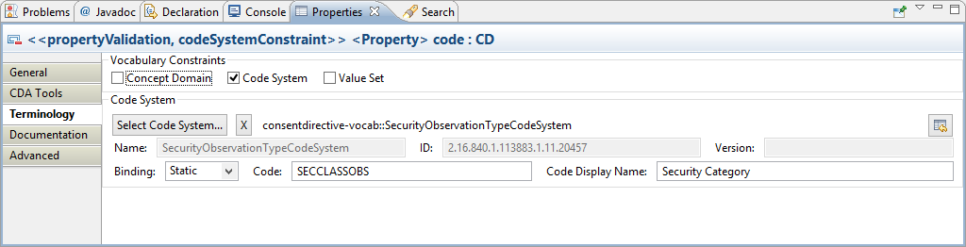

Figure 10: Coded values may be constrained to a single coded concept

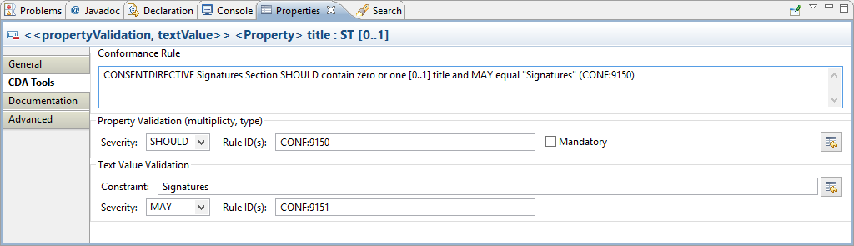

Figure 11: A string value "may" be suggested for text attributes

Assign unique identifier to each constraint predicate

Each constrain in the constrain model is uniquely identified and traced. Identifiers are very important for validation testing and for traceability.

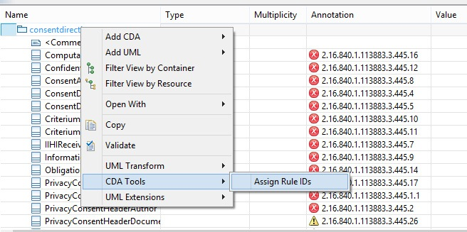

Figure 12: The constrains added to the model will have auto-generated identifiers used for traceability

Apply Constraint Model to Target Interchange Standard

The tools convert the constraints into standard-specific constraints or extensions as needed. The transformation will use the metadata stored in FHIM to identify the correct target object in the target interchange standard (e.g. CDA, NIEM. HL7 V2).

Finally, upon completing the constraint and elaboration process, the resulting IG model is used to generate both the IG document and the corresponding implementation software for reference implementations (i.e. pilots) and validation.

Appendix A: C-CDA Specifics

PSM-specific considerations

Annotation for code generation

* Documented in a UML profile
* ….

**Appendix B: NIEM Specifics**

PSM-specific consideration

Annotation for code generation

* Documented in a UML profile
* ….

**Appendix C: Specifics on Other Potential PSMs**

XDS metadata constraints example

Glossary

|  |  |
| --- | --- |
| American National Standards Institute | ANSI facilitates the development of American National Standards (ANS) by accrediting the procedures of standards developing organizations (SDOs). These groups work cooperatively to develop voluntary national consensus standards. Accreditation by ANSI signifies that the procedures used by the standards body in connection with the development of American National Standards meet the Institute’s essential requirements for openness, balance, consensus and due process.http://www.ansi.org/ |
| Application Programming Interfaces | An application programming interface (API) is a particular set of rules and specifications that a software program can follow to access and make use of the services and resources provided by another particular software program that implements that API. http://en.wikipedia.org |
| Artifact | An artifact is a classifier that represents some physical entity, a piece of information that is used or is produced by a software development process, or by deployment and operation of a system. A particular instance (or "copy") of an artifact is deployed to a node instance. |
| Biomedical Research Integrated Domain Group Model | The Biomedical Research Integrated Domain Group (BRIDG) Model is a collaborative effort engaging stakeholders from the Clinical Data Interchange Standards Consortium (CDISC), the HL7 Regulated Clinical Research Information Management Technical Committee (RCRIM TC), the National Cancer Institute (NCI) and its Cancer Biomedical Informatics Grid (caBIG®), and the US Food and Drug Administration (FDA). The BRIDG model is an instance of a Domain Analysis Model (DAM). The goal of the BRIDG Model is to produce a shared view of the dynamic and static semantics for the domain of protocol-driven research and its associated regulatory artifacts. (http://www.bridgmodel.org) |
| Business Process Modeling Notation | A standard Business Process Modeling Notation (BPMN) will provide businesses with the capability of understanding their internal business procedures in a graphical notation and will give organizations the ability to communicate these procedures in a standard manner. Furthermore, the graphical notation will facilitate the understanding of the performance collaborations and business transactions between the organizations. This will ensure that businesses will understand themselves and participants in their business and will enable organizations to adjust to new internal and B2B business circumstances quickly. |
| Centers for Disease Control and Prevention | The Centers for Disease Control and Prevention (or CDC) is a United States federal agency under the Department of Health and Human Services. It works to protect public health and safety by providing information to enhance health decisions, and it promotes health through partnerships with state health departments and other organizations. The CDC focuses national attention on developing and applying disease prevention and control (especially infectious diseases), environmental health, occupational safety and health, health promotion, injury prevention and education activities designed to improve the health of the people of the United States. (Wikipedia) |
| Certification Commission for Health Information Technology | Certification Commission for Health Information Technology (CCHIT®) is a nonprofit, 501(c)3 organization with the public mission of accelerating the adoption of health IT. Founded in 2004, and certifying electronic health records (EHRs) since 2006, the Commission established the first comprehensive, practical definition of what capabilities were needed in these systems. The certification criteria were developed through a voluntary, consensus-based process engaging diverse stakeholders, and the Certification Commission was officially recognized by the federal government as a certifying body.http://www.cchit.org/ |
| Clinical Document Architecture | The HL7 Clinical Document Architecture (CDA) is an XML-based markup standard intended to specify the encoding, structure and semantics of clinical documents for exchange. http://en.wikipedia.org/wiki/Clinical_Document_Architecture |
| Common Product Model | The Common Product Model (CPM) will be an overarching domain information model relating to the HL7 v3 modeling of any kind (or instance) of a 'product'. The definition of the term product is intentionally kept loose at this point, but will definitely include: Medication, incl. vaccines Devices used in medical services Anything else a person can be exposed to (wiki.HL7.org) |
| Component 80 - Clinical Document and Message Terminology Component | The Clinical Document and Message Terminology Component defines the vocabularies and terminologies utilized by HITSP specifications for Clinical Documents and Messages used to support the interoperable transmission of information. (Source: HITSP) |
| Computationally Independent Model | A model which is not geared to any specific operating system or computer language (fhims.org) |
| Constraint | A constraint is an expression of a business rule applied to an Information Exchange. It can restrict the values that appear within the exchange in a variety of different ways, and appear in both HITSP Specifications and in the standards those specifications select. (Source: HITSP) |
| Department of Defense | The United States Department of Defense (USDOD, DOD or DoD, initially briefly referred to as the National Military Establishment or NME) is the U.S. federal department allocated the largest level of budgetary resources and charged with coordinating and supervising all agencies and functions of the government relating directly to national security and the United States armed forces. The Department of Defense is an evolution of the Department of War. The organization and functions of the DoD are set forth in Title 10 of the United States Code. (Wikipedia) |
| Domain Specific Language (DSL) | A domain-specific language is a programming language or specification language dedicated to a particular problem domain, a particular problem representation technique, and/or a particular solution technique. |
| Draft Standard for Trial Use | Draft standards are released as Draft Standards for Trial Use (DSTF) to allow implementers to test the standards. At the end of the trial period the standard may be balloted, revised or withdrawn. |
| Dynamic Binding | A dynamically bound value set has its definitions fixed, but the values in the set may vary as new versions of the code system on which they are based are released. Intensional value sets are often dynamically bound. (Source: HITSP) |
| Electronic Health Record | The Electronic Health Record (EHR) is a longitudinal electronic record of patient health information generated by one or more encounters in any care delivery setting. Included in this information are patient demographics, progress notes, problems, medications, vital signs, past medical history, immunizations, laboratory data and radiology reports. The EHR automates and streamlines the clinician's workflow. The EHR has the ability to generate a complete record of a clinical patient encounter - as well as supporting other care-related activities directly or indirectly via interface - including evidence-based decision support, quality management, and outcomes reporting. (source: HIMSS) |
| Encoded | Information, such as diseases, procedures, and/or demographic data may be coded into discrete categories, identified by codes which may be numeric, alphabetic or a combination of these. In computer-based systems, this eases retrieval and simplifies analysis. In healthcare, 'encoded' may refer to clinical conditions or interventions coded into specific coding systems for administrative, financial, and other analyses. Among the most common coding systems are the International Classifications of Diseases (see ICD) and Current Procedural Terminology (see CPT). Another approach to coding is atomic coding, which involves assigning a value to each position in the code. (A simple example would be "35yoF " meaning "35 year old female.") Such coding systems, of which SNOMED is the most well known, are more flexible than hierarchical classifications, but may be more difficult to use. (Source: HITSP) |
| Enrollment and Eligibility and Coordination of Benefits | The FHIM domain focused on information related to healthcare insurance Enrollment and Eligibility as well as Coordination of Benefits. |
| Extensible Markup Language | Extensible Markup Language (XML) is a set of rules for encoding documents in machine-readable form. (Source: HITSP) |
| Extensional Value Set | [Adapted from HL7 Version 3 Core Principals] An extensional value set definition is an enumeration of all of the concepts within the value set. Value sets defined by extension are composed of explicitly enumerated sets of concept representations (with the code system in which they are valid). The simplest case is when the value set consists of only one code. (Source: HITSP) |
| Federal Enterprise Architecture | Federal Enterprise Architecture (FEA) is the Enterprise Architecture of a Federal Government. It provides a common methodology for information technology (IT) acquisition, use, and disposal in the Federal government. (Wikipedia) |
| Federal Health Architecture | The Federal Health Architecture (FHA) is an E-Government Line of Business initiative managed by the Office of the National Coordinator for Health IT. FHA was formed to coordinate health IT activities among the more than 20 federal agencies that provide health and healthcare services to citizens. (hhs.gov) |
| Federal Health Information Model | FHIM is a modeling initiative focused on producing a logical, health information model that supports semantic interoperability among federal agencies and their health information exchange partners. The model is built by harmonizing information from federal partners and standards development organizations (SDOs) and presenting it in logical and conceptual views based on specialized health domains.This logical model uses the HL7 Reference Information Model (RIM) as its reference model and is designed to support multiple Office of Interoperability and Standards initiatives, including CONNECT and the S&I Framework. FHA and its stakeholders also use the FHIM to view and analyze information exchanges that have been identified by federal partners and SDOs, and the FHIM model is also used to support the development of National Information Exchange Model (NIEM) compliant information exchanges by the S&I Framework. |
| Federal Segment Architecture Methodology | The Federal Segment Architecture Methodology (FSAM) is a step-by-step process for developing and using segment architectures that was developed by distilling proven best practices from across Federal agencies. Use of the FSAM should result in more complete and consistent segment architecture products and will result in greater reuse of segment architectures by providing key information that informs downstream processes for capital planning, security (e.g. certification and accreditation), and the system development life cycle. (fsam.gov) |
| Food and Drug Administration | The Food and Drug Administration (FDA or USFDA) is an agency of the United States Department of Health and Human Services, one of the United States federal executive departments. The FDA is responsible for protecting and promoting public health through the regulation and supervision of food safety, tobacco products, dietary supplements, prescription and over-the-counter pharmaceutical drugs (medications), vaccines, biopharmaceuticals, blood transfusions, medical devices, electromagnetic radiation emitting devices (ERED), veterinary products, and cosmetics. (Wikipedia) |
| Harmonization | Harmonization is the name given to the effort by industry to replace the variety of product standards and other regulatory policies adopted by nations, in favor of uniform global standards. Usually used to in the context of trade agreements, harmonization has recently been adopted by the United States government to refer to information technology standards. (Source: HITSP) |
| Health Information Technology Standards Panel | The Healthcare Information Technology Standards Panel (HITSP) is a cooperative partnership between the public and private sectors. The Panel was formed for the purpose of harmonizing and integrating standards that will meet clinical and business needs for sharing information among organizations and systems. (Source: HITSP) |
| Health Insurance Portability and Accountability Act | The Health Insurance Portability and Accountability Act (HIPAA) of 1996 (P.L.104-191) [HIPAA] was enacted by the U.S. Congress in 1996. It was originally sponsored by Sen. Edward Kennedy (D-Mass.) and Sen. Nancy Kassebaum (R-Kan.). According to the Centers for Medicare and Medicaid Services (CMS) website, Title I of HIPAA protects health insurance coverage for workers and their families when they change or lose their jobs. Title II of HIPAA, known as the Administrative Simplification (AS) provisions, requires the establishment of national standards for electronic health care transactions and national identifiers for providers, health insurance plans, and employers. |
| Health Level Seven International | Founded in 1987, Health Level Seven International (HL7) is a not-for-profit, ANSI-accredited standards developing organization dedicated to providing a comprehensive framework and related standards for the exchange, integration, sharing, and retrieval of electronic health information that supports clinical practice and the management, delivery and evaluation of health services.http://www.hl7.org/ |
| HITSP EHR Lab Result Terminology Component | The Lab Result Terminology Component defines the vocabulary for either message-based or document-based laboratory results reporting. (Source: HITSP) |
| HITSP Lab Report Document Component | The Lab Report Document Component prescribes the use of the standard Clinical Document Architecture Release 2 (CDA R2), as in the HL7 V3 2006 normative edition profiled by IHE LAB TF-3 for: transmission of complete, preliminary, final and updated laboratory results to the EHR system (local or remote) of the ordering clinician; transmission of complete, preliminary, final and updated (or notification) to the EHR system (local or remote) or other clinical data system of designated providers of care (with respect to a specific patient); transmission of laboratory result data from electronically enabled healthcare delivery and public health systems in standardized and anonymized format to authorized Public Health Agencies with less than one day lag time (Source: HITSP) |
| HITSP Lab Result Message Component | The Lab Result Message Component describes the use of a constrained Health Level Seven (HL7) Version 2.5.1 ORU – Unsolicited Observation Message for electronic laboratory results reporting (Source: HITSP) |
| HL7 Electronic Health Record System Functional Model | The HL7 EHR System Functional Model provides a reference list of over 160 functions that may be present in an Electronic Health Record System (EHR-S). The function list is described from a user perspective with the intent to enable consistent expression of system functionality. This EHR-S Functional Model, through the creation of Functional Profiles, enables a standardized description and common understanding of functions sought or available in a given setting (e.g. intensive care, cardiology, office practice in one country or primary care in another country). Source: http://www.hl7.org/ehr/downloads/index_2007.asp) |
| HL7 Implementation Technology Specification | Generally an ITS is a specification that describes a method of encoding HL7 artifacts. The ITS specifies how abstract models should be transformed into on-the-wire things (e.g. a string, or an object) that can be transmitted (http://wiki.hl7.org/index.php?title=Implementable_Technology_Specification) |
| HL7 Individual Case Safety Report | The HL7 Individual Case Safety Report (ICSR) is a Health Level Seven (HL7) standard for the exchange of adverse event or product problem reports to public health, patient safety, healthcare quality improvement organizations or regulatory authorities. Release 1 of the standard supports reporting for drugs, therapeutic biologics, blood derivatives, devices and vaccines. Release 2 of the standard is being balloted to support other product types such as foods, food additives, dietary supplements, cosmetics and veterinary drugs. (HL7.org) |
| HL7 Reference Information Model | The Reference Information Model (RIM) is the cornerstone of the HL7 Version 3 development process. An object model created as part of the Version 3 methodology, the RIM is a large, pictorial representation of the HL7 clinical data (domains) and identifies the life cycle that a message or groups of related messages will carry. It is a shared model between all domains and, as such, is the model from which all domains create their messages. The RIM is an ANSI approved standard. http://www.hl7.org/implement/standards/rim.cfm |
| Information Exchange | Bidirectional information transmission/information transfer in telecommunications and computer science |
| Information Exchange Package Documentation | An IEPD, or Information Exchange Package Documentation, is a specification for a data exchange and defines a particular data exchange. For example, there is an IEPD that defines the information content and structure for an Amber Alert, a bulletin or message sent by law enforcement agencies to announce the suspected abduction of a child. It is a set of artifacts consisting of normative exchange specifications, examples, metadata, and documentation encapsulated by a catalog that describes each artifact. The entire package is archived as a single compressed file. When uncompressed, the catalog is a hyperlinked index into the IEPD and can be opened in a standard browser. The user may use the catalog to overview the IEPD contents or to open each individual artifact (provided the appropriate software required to open a given artifact is installed). http://www.niem.gov/whatIsAnIepd.php--------------------from NHIN 201 FINAL 100110 InteropStandards OverviewAn Information Exchange Package Documentation (IEPD) is a collection of artifacts that describe the construction and content of an information exchange.•Developed to provide the business, functional, and technical details of the information exchange through predefined artifacts•Created with a core set of artifacts in a prescribed format and organizational structure to allow for consistency•Designed to be shared and reused in the development of new information exchanges through publication in IEPD repositories•IEPDs contain design specifications for an information exchange but may not include supplementary information such as implementation decisions. |
| Integrating the Healthcare Enterprise | IHE is an initiative by healthcare professionals and industry to improve the way computer systems in healthcare share information. IHE promotes the coordinated use of established standards such as DICOM and HL7 to address specific clinical need in support of optimal patient care. http://www.ihe.net/ |
| Intensional Value Set | [Adopted from HL7 Version 3 Core Principals] An intensional value set definition is a set of rules that can be resolved (ideally computationally) to an exact list of concept representations at a particular point in time. (Source: HITSP) |
| International Business Machines | International Business Machines (IBM) (NYSE: IBM) is an American multinational technology and consulting firm headquartered in Armonk, New York. IBM manufactures and sells computer hardware and software, and it offers infrastructure, hosting and consulting services in areas ranging from mainframe computers to nanotechnology. http://en.wikipedia.org/wiki/IBM |
| International Organization for Standardization | ISO (International Organization for Standardization) is the world's largest developer and publisher of International Standards. ISO is a non-governmental organization that forms a bridge between the public and private sectors. On the one hand, many of its member institutes are part of the governmental structure of their countries, or are mandated by their government. On the other hand, other members have their roots uniquely in the private sector, having been set up by national partnerships of industry associations. http://www.iso.org/iso/home.html |
| Interoperability | Interoperability is the ability of health information systems to work together within and across organizational boundaries, in order to advance the effective delivery of health care for individuals and communities. (Source: HITSP) |
| Interoperability Specification 01 - Electronic Health Record (EHR) Laboratory Results Reporting | The Electronic Health Records Laboratory Results Reporting Interoperability Specification defines specific standards to support the interoperability between electronic health records and laboratory systems and secure access to laboratory results and interpretations in a patient-centric manner. (Source: HITSP) |
| Logical Observation Identifiers Names and Codes | LOINC laboratory terms set provides a standard set of universal names and codes for identifying individual laboratory and clinical results, and allows users to merge clinical results from many sources into one database for patient care, clinical research, or management. (Source: HITSP) |
| Metamodeling | Metamodeling, or meta-modeling in software engineering and systems engineering among other disciplines, is the analysis, construction and development of the frames, rules, constraints, models and theories applicable and useful for modeling a predefined class of problems. As its name implies, this concept applies the notions of meta- and modeling. (Source: Wikipedia: [http://en.wikipedia.org/wiki/Metamodeling#Metadata_modeling](http://en.wikipedia.org/wiki/Metamodeling)) |
| Military Health System | The Military Health System is the enterprise within the United States Department of Defense responsible for providing health care to active duty and retired U.S. Military personnel and their dependents.http://www.health.mil/ |
| Model-Driven Architecture | Model-driven architecture (MDA) is a software design approach for the development of software systems. It provides a set of guidelines for the structuring of specifications, which are expressed as models. Model-driven architecture is a kind of domain engineering, and supports model-driven engineering of software systems. It was launched by the Object Management Group (OMG) in 2001 (Wikipedia) |
| Model-Driven Health Tools | The Model-Driven Health Tools (MDHT) Project focuses on the development and promotion of model-driven Health Information standards within the standards community by providing a unified set of modeling tools for standards organizations and standard implementers to design, publish, and implement standards such as Clinical Document Architecture all from a UML model.https://www.projects.openhealthtools.org/sf/projects/mdht/ |
| Model Package Description | A compressed archive of files that contains one and only one of the four classes of NIEM IEMs, as well as supporting documentation and artifacts. http://www.niem.gov/newsletter201102.php |
| National Cancer Institute | The National Cancer Institute (NCI) is part of the National Institutes of Health (NIH), which is one of 11 agencies that are part of the U.S. Department of Health and Human Services. The NCI coordinates the U.S. National Cancer Program and conducts and supports research, training, health information dissemination, and other activities related to the causes, prevention, diagnosis, and treatment of cancer; the supportive care of cancer patients and their families; and cancer survivorship. (Wikipedia) |
| National Information Exchange Model | The National Information Exchange Model (NIEM) is a Federal, State, Local and Tribal interagency initiative providing a foundation for seamless information exchange. (Source: <http://www.niem.gov/>) |
| Nationwide Health Information Network | The nationwide health information network is a set of standards, services and policies that enable secure health information exchange over the Internet. The network will provide a foundation for the exchange of health information across diverse entities, within communities and across the country, helping to achieve the goals of the HITECH Act. This critical part of the national health IT agenda will enable health information to follow the consumer, be available for clinical decision making, and support appropriate use of healthcare information beyond direct patient care so as to improve population health. (Source: <http://healthit.hhs.gov/portal/server.pt?open=512&mode=2&cached=true&objID=1142>) |
| NEIM Tool Architecture | The NIEM TA is an open plan intended to leverage existing off-the-shelf tools and facilitate new software tools and value-added capabilities that can support NIEM and its stakeholders. |
| NIEM Business Architecture Committee | NBAC exists to ensure that the technical solutions that are built as part of the NIEM initiative are derived from and driven by the needs of practitioners to share information across boundaries. NBAC must focus its work on drawing from the field the requirements, use cases, and general needs for improved information sharing. http://niem.gov/newsletter20080530.php |
| NIEM Naming and Design Rules | The naming and design rules for NIEM are documented in the NIEM NDR, which specifies the data model, XML components, and XML data for use with NIEM and provides a basis for NIEM conformance. The current version is NDR v1.3, which was released on 2008-10-31.NIEM is based on several concepts from the International Organization for Standardization (ISO) 11179, which provides guidelines for the naming and definition of data elements, as well as information about the metadata captured about data elements. Part 5 of the ISO 11179 standard establishes a methodology for naming items in data dictionaries. http://en.wikipedia.org/wiki/National_Information_Exchange_Model#NIEM_Naming_and_Design_Rules_.28NDR.29 |
| NIEM Program Management Office | The NIEM Program Management Office (PMO) operates to:Bring stakeholders, agencies, and the domains and COIs that they represent together to identify information sharing requirements in daily operational and emergency situations; Develop information sharing standards, a common lexicon, and an online repository of information exchange package documentation and data components that support information sharing; Provide technical tools, processes, and methodologies to support the analysis, development, discovery, dissemination, and reuse of exchange standards and documents; and Provide training, technical assistance, communication, outreach, and implementation support services for NIEM-based information sharing. http://en.wikipedia.org/wiki/National_Information_Exchange_Model#NIEM_Program_Management_Office |
| Object Identifier | In computing, an object identifier or OID is an identifier used to name an object (compare URN). Structurally, an OID consists of a node in a hierarchically-assigned namespace, formally defined using the ITU-T's ASN.1 standard. (Wikipedia) |
| Object Management Group | Object Management Group (OMG) is a consortium, originally aimed at setting standards for distributed object-oriented systems, and is now focused on modeling (programs, systems and business processes) and model-based standards. http://en.wikipedia.org/wiki/Object_Management_Group |
| Office of the National Coordinator for Health IT | The Office of the National Coordinator for Health Information Technology (ONC) is at the forefront of the administration’s health IT efforts and is a resource to the entire health system to support the adoption of health information technology and the promotion of nationwide health information exchange to improve health care. ONC is organizationally located within the Office of the Secretary for the U.S. Department of Health and Human Services (HHS).http://healthit.hhs.gov/portal/server.pt/community/healthit_hhs_gov__home/1204 |
| Platform Definition Model (PDM) | A platform definition model defines the rules to transform the PIM into a PSM. |
| Platform Independent Model | A model of a software or business system independent of the specific technological platform used to implement it. |
| Platform Specific Model | A model of a software or business system that is linked to a specific technological platform (e.g. a specific programming language, operating system or database). |
| President's Council of Advisors on Science and Technology | The United States President's Council of Advisers on Science and Technology (PCAST) is a council, established by Executive Order 13226 on September 30, 2001, with a broad mandate to advise the President on science and technology. http://en.wikipedia.org/wiki/PCAST |
| Public Health Conceptual Data Model | The purpose of the Public Health Conceptual Data Model is to document theinformation needs of public health so that the Centers for Disease Control andPrevention (CDC) and its state and local partners in public health can:•Establish data standards for public health, including data definitions,component structures (such as for complex datatypes), code values, and datause;• Collaborate with national health informatics standards setting bodies to definestandards for the exchange of information among public health agencies, andhealthcare providers;•Construct computerized information systems that conform to established dataand data interchange standards for use in the management of data relevant topublic health. (cdc.gov) |
| Query/View/Transformation (QVT) | QVT (Query/View/Transformation), in the model-driven architecture, is a standard for model transformation defined by the Object Management Group. (Source: Wikipedia: http://en.wikipedia.org/wiki/QVT) |
| Resource Description Framework | The Resource Description Framework (RDF) is a family of World Wide Web Consortium (W3C) specifications originally designed as a metadata data model. It has come to be used as a general method for conceptual description or modeling of information that is implemented in web resources, using a variety of syntax formats. (Source: Wikipedia: http://en.wikipedia.org/wiki/Resource_Description_Framework) |
| Semantic Model Metadata Mapping | The ability to define the structural constraints that allow the semantic meaning of one model to be mapped to another. |
| Semantic Model Metadata | Semantic Model Metadata refers to the key words and stereotypes that have to be added to the FHIM to make it transformable into the target representation implementation (e.g., CDA R2 document model, NIEM extensions, HL7 V3 XSD, HL7 Version 2 XML profiles, as well as other technologies). |
| Service-Oriented Architecture | In computing, a service-oriented architecture (SOA) is a flexible set of design principles used during the phases of systems development and integration. A deployed SOA-based architecture will provide a loosely-integrated suite of services that can be used within multiple business domains. (Source: Wikipedia: http://en.wikipedia.org/wiki/Service-oriented_architecture) |
| Standards and Interoperability Framework | The S&I Framework is the mechanism by which ONC will manage the implementation of specifications and the harmonization of existing health IT standards to promote interoperability nationwide. The S&I Framework supports the entire specification lifecycle, from identifying the need for specifications through to creating/harmonizing standards and testing for compliance. The Framework functions within each phase of the specification process by coordinating efforts among public and private sector stakeholders as they work together to: develop content and technical specifications; develop reusable tools and services; and unite stakeholders around common healthcare challenges. |
| Standards Development Organizations | A standards organization, standards body, standard-developing organization (SDO), or standard-setting organization (SSO) is any organization whose primary activities are developing, coordinating, promulgating, revising, amending, reissuing, interpreting, or otherwise maintaining technical standards that address the interests of a wide base of users outside the standard-developing organization. (Wikipedia) |
| Static Binding | The values in the value set are fixed until a new version of the value set is released. Extensional Value Sets are typically statically bound. When an intensional value set is statically bound, the version of the code system being used must be specified before the members of the value set can be computed. (Source: HITSP) |
| Structured Product Labeling | The Structured Product Labeling (SPL) is a document markup standard approved by Health Level Seven (HL7) and adopted by FDA as a mechanism for exchanging product information. (fda.gov) |
| Subject Matter Expert | A subject matter expert (SME) or domain expert is a person who is an expert in a particular area or topic. (Wikipedia) |
| Subset Schema Generation Tool (SSGT) | The Schema Subset Generation Tool (SSGT) enables users to search through the NIEM data model and build a NIEM subset. The NIEM data model covers several domains and typically not the entire data model is usable in an exchange. It is useful to make a schema subset of NIEM components to use in an exchange. It helps to limit the scope of developing an IEPD and can be built to the specific requirements of an exchange. http://en.wikipedia.org/wiki/National_Information_Exchange_Model#Schema_Subset_Generation_Tool |
| Systematized Nomenclature of Medicine- Clinical Terms | A structured nomenclature and classification of the terminology used in human and veterinary medicine developed by the College of Pathologists and American Veterinary Medical Association. Terms are applied to one of eleven independent systematized modules. (Source: HITSP) |
| Terminology Model | A terminology model is a collection of terminology artifacts that, together, support defining the terminology constraints that can apply in standard specifications. The specific types of artifacts that a terminology model may contain include:  [Concept Domains](http://wiki.hl7.org/index.php?title=Requirements-Concept_Domains)  [Code Systems](http://wiki.hl7.org/index.php?title=Requirements-Code_Systems)  [Value Sets](http://wiki.hl7.org/index.php?title=Requirements-Value_Sets)  [Binding Realms](http://wiki.hl7.org/index.php?title=Requirements-Binding_Realms)  [Context Bindings](http://wiki.hl7.org/index.php?title=Requirements-Context_Binding)  [Code Translations](http://wiki.hl7.org/index.php?title=Requirements-Code_Translations)  [Code System Supplements](http://wiki.hl7.org/index.php?title=Requirements-Code_System_Supplements)  (Source: HL7 Wiki: [Requirements Terminology Model](http://wiki.hl7.org/index.php?title=Requirements-Terminology_Model)) |
| Terminology Binding | A formally expressible connection between an information model representation and a terminology representation of a clinical statement represented in an EHR (Source: OpenEHR) |
| U.S Citizenship and Immigration Services | USCIS provides immigration information, grants benefits, promotes awareness and understanding of citizenship and ensures the integrity of the immigration system. www.uscis.gov |
| U.S. Department of Veterans Affairs | The United States Department of Veterans Affairs (VA) is a government-run military veteran benefit system with Cabinet-level status. It is the United States government’s second largest department, after the United States Department of Defense. (Wikipedia) |
| Universal Modeling Language | An ISO (International Standard) specification, graphical visualization language for modeling objects. It's a refinement of earlier Object Oriented Design and Object Oriented Analysis methodologies. It consists of a series of symbols and connectors that can be used to create process diagrams and is often used to model computer programs and workflows. |
| UML Profile | A profile in the Unified Modeling Language (UML) provides a generic extension mechanism for customizing UML models for particular domains and platforms. Extension mechanisms allow refining standard semantics in strictly additive manner, so that they can't contradict standard semantics. A UML profile consists of Stereotype, Constraint, Tag Definition and Data Type elements. |
| Veterans Affairs Health Information Model | The VHA Health Information Model (VHIM) is the authoritative enterprise information model for Veterans Health Administration (VHA), representing the structure and content of all shared information that is exchanged across the enterprise. http://www.va.gov/VHIM/ |
| Web Ontology Language | The Web Ontology Language (OWL) is a family of knowledge representation languages for authoring ontologies. The languages are characterized by formal semantics and RDF/XML-based serializations for the Semantic Web. OWL is endorsed by the World Wide Web Consortium (W3C)[1] and has attracted academic, medical and commercial interest. http://en.wikipedia.org/wiki/Web_Ontology_Language |
| XML Metadata Interchange | The XML Metadata Interchange (XMI) is an Object Management Group (OMG) standard for exchanging metadata information via Extensible Markup Language (XML).It can be used for any metadata who’s metamodel can be expressed in Meta-Object Facility (MOF).The most common use of XMI is as an interchange format for UML models, although it can also be used for serialization of models of other languages (metamodels). <http://en.wikipedia.org/wiki/XMI> |
| XML Schema | An XML schema is a description of a type of XML document, typically expressed in terms of constraints on the structure and content of documents of that type, above and beyond the basic syntactical constraints imposed by XML itself. These constraints are generally expressed using some combination of grammatical rules governing the order of elements, Boolean predicates that the content must satisfy, data types governing the content of elements and attributes, and more specialized rules such as uniqueness and referential integrity constraints. (Source: Wikipedia: http://en.wikipedia.org/wiki/XML_schema) |